1. What are the different types of statements supported by SQL?
2. **What is the difference between DELETE and TRUNCATE statement?**
3. What is SQL?
4. How do we use the DISTINCT statement? What is its use?
5. **What is the difference between the CHAR and VARCHAR2 datatype in SQL?**

#### ****What is a primary key, a foreign key, and a unique key?****

#### What is a composite key?

#### ****What is the difference between SQL and MySQL?****

#### Why do we use SQL constraints? ****Explain SQL constraints.****

1. What is Normalization? How many Normalization forms are there?
2. Define join and name different types of joins?

### Which operator is used in query for pattern matching?

1. Apply **First Normal Form ,** **Second Normal Form and Third Normal Form on below table**

**Students Table**

|  |  |  |  |
| --- | --- | --- | --- |
| **Student** | **Address** | **Books Issued** | **Salutation** |
| Raja | Amanora Park Town 94 | Until the Day I Die (Emily Carpenter), Inception (Christopher Nolan) | Mr. |
| Omkar | 62nd Sector A-10 | The Alchemist (Paulo Coelho), Inferno (Dan Brown) | Mr. |
| Raja | 24th Street Park Avenue | Beautiful Bad (Annie Ward), Woman 99 (Greer Macallister) | Mr. |
| Omkar | Windsor Street 777 | Dracula (Bram Stoker) | Mr. |

### How to select unique records from a table? Write query

1. **What are aggregate functions?**

### What are some common clauses used with SELECT query in SQL?

### ****Write a SQL query to find the names of employees that begin with ‘A’?****

### Write the SQL query to get the ****second highest,**** third ****highest**** salary of an employee from a table named employees.

### Employee table

|  |  |
| --- | --- |
| employee_name | salary |
| A | 24000 |
| C | 34000 |
| D | 55000 |
| E | 75000 |
| F | 21000 |
| G | 40000 |
| H | 50000 |

**19.How to remove duplicate rows in SQL on below table.**

|  |  |  |
| --- | --- | --- |
| ID | Name | Age |
| 1 | A | 21 |
| 2 | B | 23 |
| 2 | B | 23 |
| 4 | D | 22 |
| 5 | E | 25 |
| 6 | G | 26 |
| 5 | E | 25 |

**What is the difference between LEFT, RIGHT, FULL outer join and INNER join?**

**Write sql joins query on below tables.**

**Employee Table**

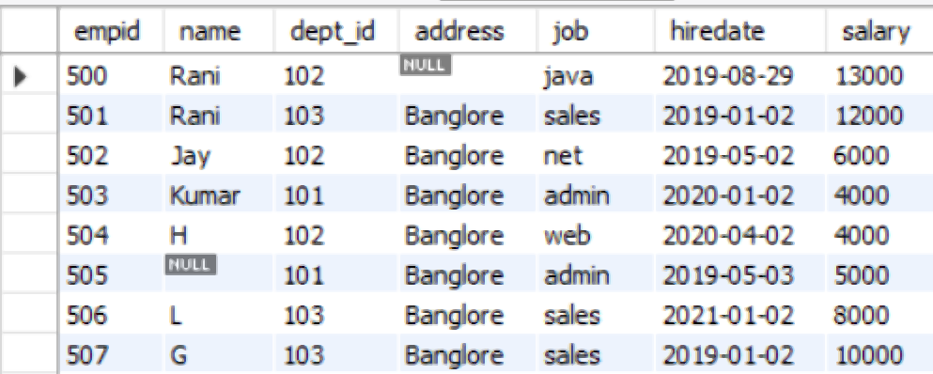

**Department Table**

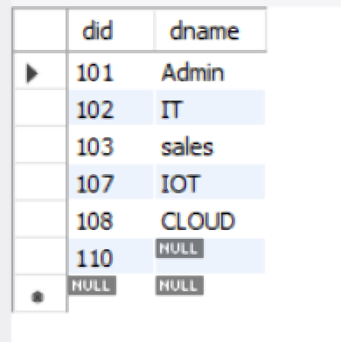

**Imagine there is a FULL_NAME column in a table which has values like “Elon Musk“, “Bill Gates“, “Jeff Bezos“ etc. So each full name has a first name, a space and a last name. Which functions would you use to fetch only the first name from this FULL_NAME column? Give example.**

**Q38. How to remove duplicate rows in SQL?**

DELETE FROM table WHERE ID IN (  
SELECT    
ID, COUNT(ID)    
FROM   table  
GROUP BY  ID  
HAVING    
COUNT (ID) > 1);

Reference link for sql interview

<https://www.guru99.com/sql-interview-questions-answers.html>

<https://intellipaat.com/blog/interview-question/sql-interview-questions/>

<https://techtfq.com/blog/top-20-sql-interview-questions#google_vignette>

<https://artoftesting.com/sql-queries-for-interview>

https://www.edureka.co/blog/interview-questions/sql-interview-questions